Supplementary material

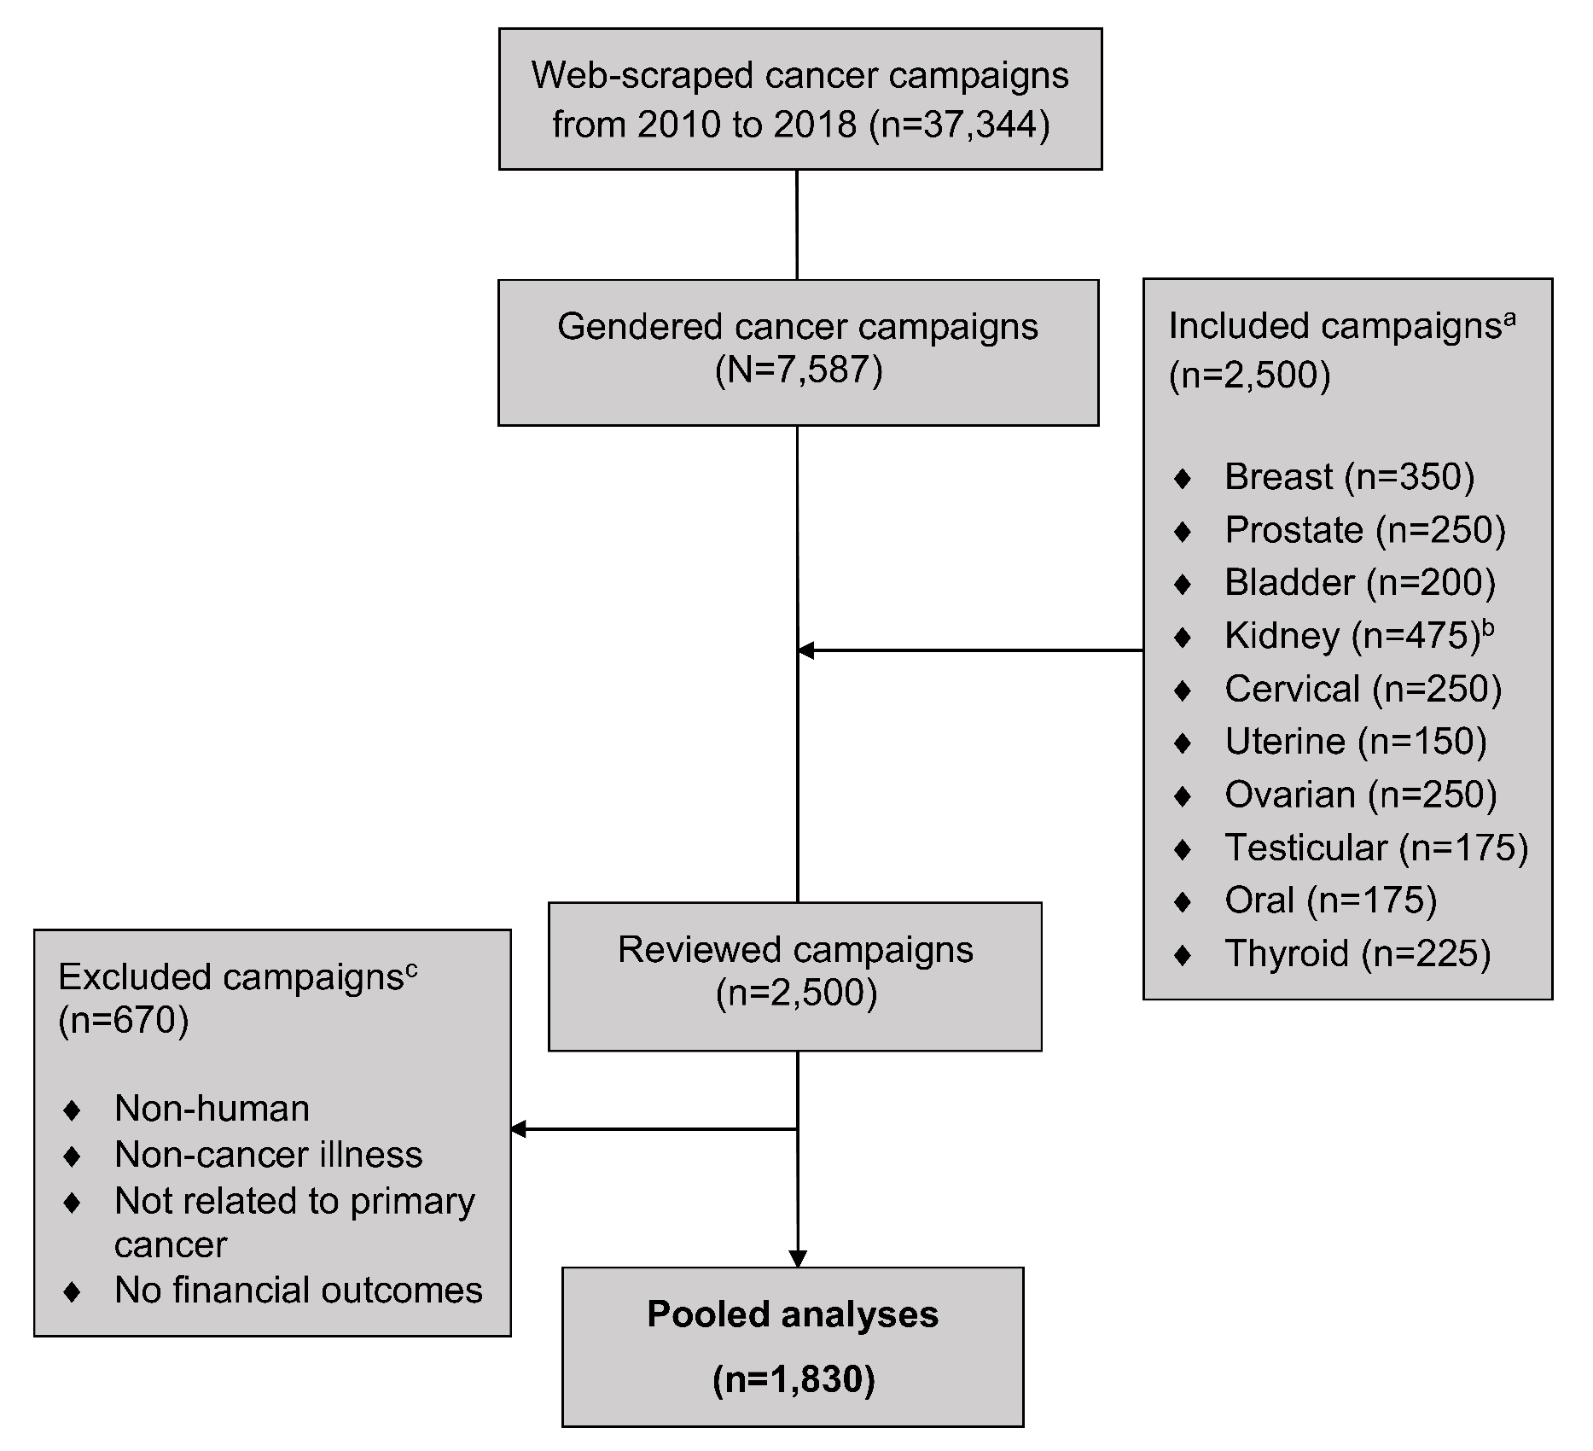
Supplementary Fig. 1. CONSORT diagram representing web-scraping results and selection criteria for current cross-sectional study. ªCampaigns included in present study were selected randomly for review. ^{b}All kidney cancer campaigns were reviewed for the purpose of a concurrent study and included in present study. ^{c}Several campaigns met one or more of the listed exclusion criteria.

Supplementary Table 1. Fundraising variables by cancer type.
Fundraising Variables: Median (IQR)
Cancer Type | Campaigns  (2205 reviewed) | Estimated Pop. Campaigns | Amount Raised (USD) | Amount Goal (USD) | Percent Goal Raised | Number of Donations | Number of Shares | Est. Total Pop. Funding  95% CI (not shown)
Bladder | 104 | 208 | 1617.5 (650, 3832.5) | 6000 (4750, 13,500) | 21 (9, 51) | 19 (8, 38) | 137.5 (51.5, 281) | $685,000
Female | 23 | 46 | 1610 (810, 3652) | 5000 (4000, 10,000) | 26 (12, 81) | 19 (10, 38) | 226 (60, 386) | $124,000
Male | 78 | 156 | 1650 (640, 4165) | 6000 (4500, 15000) | 21 (7, 50) | 18.5 (7, 39) | 121 (44, 267) | $554,000
Breast | 271 | 3682 | 1695 (706, 4828) | 8000 (5000, 15000) | 24 (9, 60) | 21 (10, 53) | 152 (62, 336) | $15,272,000
Prostate | 157 | 377 | 1343 (445, 3635) | 6850 (4000, 11500) | 21 (8, 55) | 20 (6, 40) | 125 (43, 227) | $1,316,000
Cervical | 209 | 474 | 1330 (610, 3000) | 8410 (4000, 15000) | 18 (8, 44) | 17 (9, 39) | 152 (75, 339) | $1,279,000
Kidney | 475 | 475 | 1450 (575, 4050) | 10000 (5000, 20000) | 21 (7, 52) | 17 (8, 42) | 154 (65, 351) | $1,780,000
Female | 170 | 170 | 1365 (500, 3290) | 10000 (3300, 15000) | 21 (9, 48) | 18.5 (9, 38) | 145.5 (69, 367) | $531,000
Male | 292 | 292 | 1672.5 (640, 4485) | 10000 (5000, 20000) | 21 (7, 54) | 17.5 (8, 46.5) | 164 (65, 350.5) | $1,205,000
Oral | 63 | 91 | 2530 (965, 4620) | 10000 (5000, 15000) | 33 (12, 63) | 28 (15, 64) | 247 (107, 404) | $413,000
Female | 19 | 27 | 1800 (820, 3840) | 10000 (5000, 15000) | 19 (9, 39) | 22 (11, 68) | 141 (63, 354) | $124,000
Male | 42 | 61 | 2637.5 (1160, 5125) | 9000 (5000, 15000) | 33 (12, 68) | 28.5 (15, 47) | 268.5 (119, 508) | $554,000
Ovarian | 174 | 452 | 2018 (900, 4560) | 10000 (5000, 15000) | 29 (14, 53) | 26.5 (14, 49) | 146.5 (70, 288) | $1,675,000
Testicular | 118 | 173 | 3371 (1240, 10127)  p < 0.0001* | 10000 (5000, 25000) | 36 (13, 71) | 42 (17, 93) | 342.5 (154, 705) | $1,329,000
Thyroid | 135 | 286 | 1525 (550, 2975) | 7200 (500, 10000) | 24 (9, 50) | 24 (10, 40) | 177 (77, 353) | $739,000
Female | 93 | 197 | 1530 (685, 3115) | 7500 (5000, 10000) | 27 (10, 50) | 25 (14, 40) | 171 (83, 357) | $451,000
Male | 37 | 78 | 1630 (550, 2660) | 6000 (3500, 10000) | 24 (15, 49) | 22 (7, 37) | 196 (65, 341) | $281,000
Uterine | 118 | 149 | 1200 (550, 3125) | 5750 (3000, 10000) | 25 (8, 57) | 18.5 (9, 34) | 137 (61, 248) | $354,000
Total | 1816 | 6367 |  |  |  |  |  | $24,842,000
*Wilcoxon rank-sum significant with Bonferroni adjustment (0.05/9) for all except testicular-oral.

